 |  |  | CS118 |  |  |  | LAB 11
 |  | Programming |  |  |  |  | LAB 11
 |  |  |  |  |  |  | Dynamic Memory Allocation + Structures
 | Fundamentals |  |  |  |  |  | Dynamic Memory Allocation + Structures

NATIONAL UNIVERSITY OF COMPUTER AND EMERGING SCIENCES

Structure of Structures / Nested Structures

If one of the member of a structure is itself a structure then the parent structure is called as the structure of structure. It is also termed as nested structure. You can nest as many structures as required i.e. there is no any limitation on the levels of nested structures.

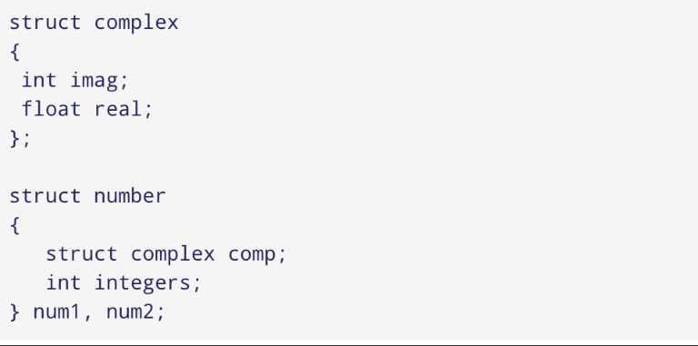

Accessing Value in Nested Structure:

num2.comp.imag = 11;

Structure With Functions

You can pass a structure as a function argument in very similar way as you pass any other variable or pointer.

Syntax:

int myFunction(struct Person p){

...

}

You would access structure variables in the similar way as you have accessed in the above example:

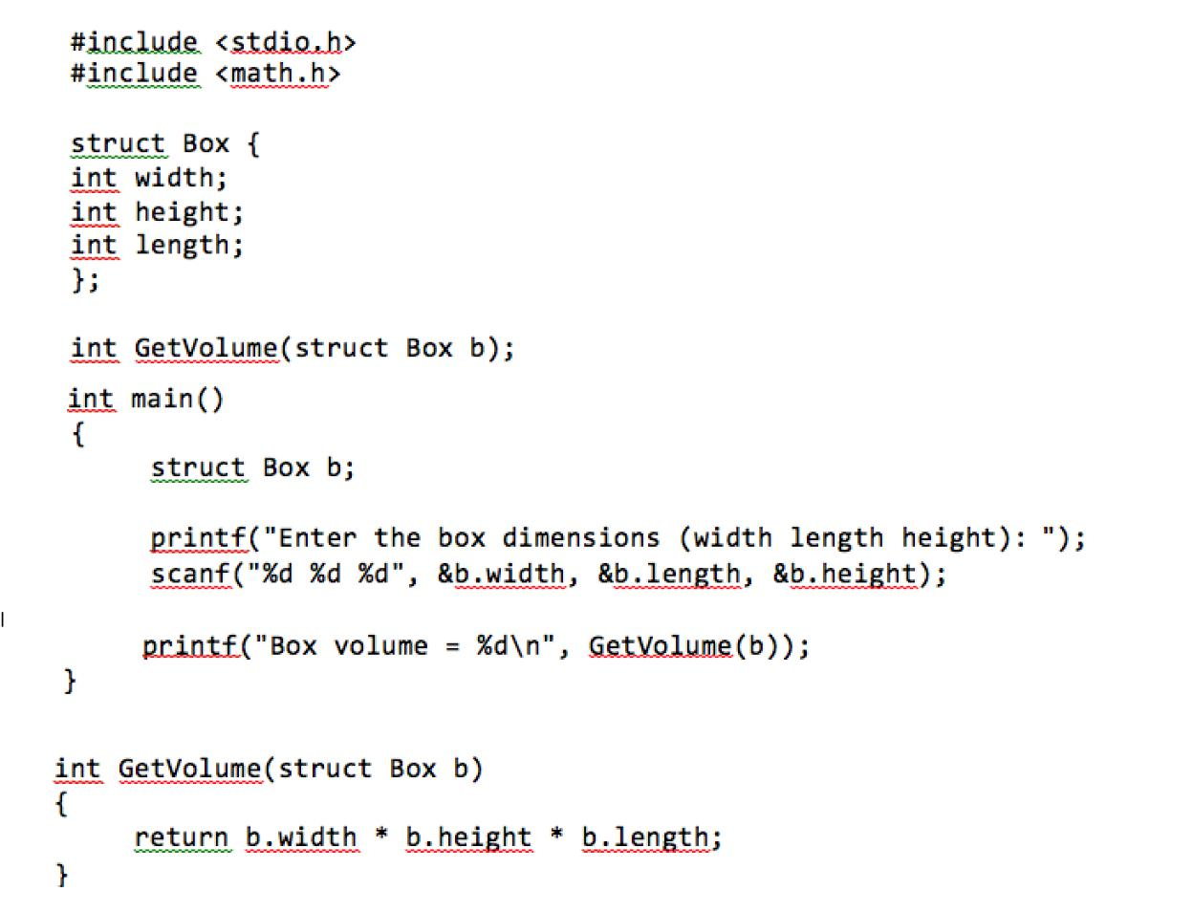

Pointers to Structures

- Defining pointers to structures in very similar way as you define pointer to any other variable as follows:

struct Books *struct_pointer;

- Store the address of a structure variable in the above defined pointer variable. To find the address of a structure variable, place the & operator before the structure's name as follows:

struct_pointer = &Book1;!

- To access the members of a structure using a pointer to that structure, you must use the -> operator as follows:

struct_pointer->title;


#include <stdio.h>

#include <string.h>

struct Books

{

char title[50];

char author[50];
char subject[100];
int book_id;

};

/* function declaration */

void printBook( struct Books *book );
int main( )

{

struct Books Book1; struct Books Book2;
/* Declare Book1 of type Book */

/* Declare Book2 of type Book*/

/* book 1 specification */

strcpy( Book1.title, "CProgramming");

strcpy( Book1.author, "Nuha Ali");

strcpy( Book1.subject, "C ProgrammingTutorial");

Programming Fundamental Lab


Book1.book_id = 6495407;

/* book 2 specification */

strcpy( Book2.title, "TelecomBilling");

strcpy( Book2.author, "Zara Ali");

strcpy( Book2.subject, "Telecom Billing Tutorial"); Book2.book_id = 6495700;

/* print Book1 info by passing address of Book1 */ printBook( &Book1 );

/* print Book2 info by passing address of Book2 */ printBook( &Book2 );

return 0;

}

void printBook( struct Books *book )

{

printf( "Book title : %s\n", book->title);

printf( "Book author : %s\n", book->author);

printf( "Book subject : %s\n", book->subject);

printf( "Book book_id : %d\n", book->book_id);

}

Programming Fundamental Lab

Another Example:
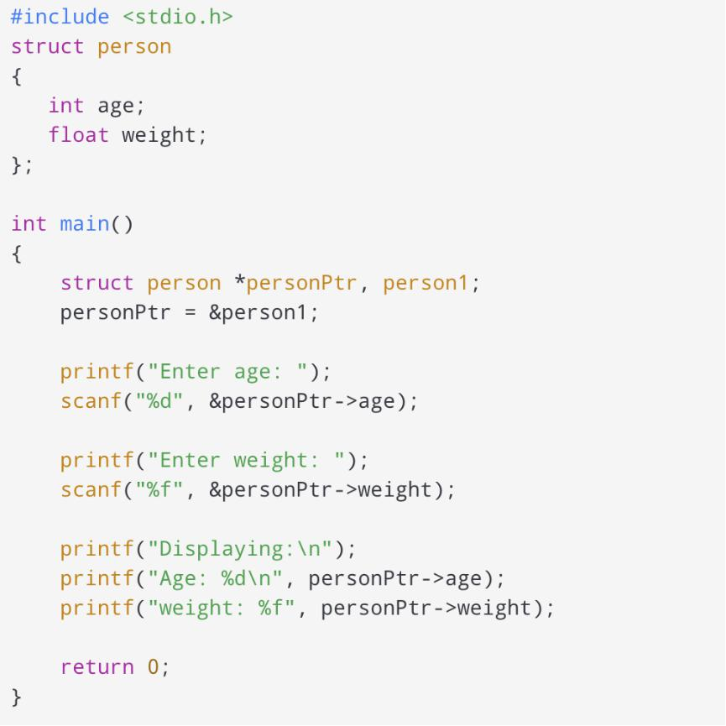

Dynamic Memory Allocation

As you know, an array is a collection of a fixed number of values. Once the size of an array is declared, you cannot change it. Sometimes the size of the array you declared may be insufficient. To solve this issue, you can allocate memory manually during run-time. This is known as dynamic memory allocation in C programming.

To allocate memory dynamically, library functions are malloc(), calloc(), realloc() and free() are used. These functions are defined in the <stdlib.h> header file.

Function | Purpose
malloc | Allocates the memory of requested size and returns the pointer to the first byte of
 | allocated space.
calloc | Allocates the space for elements of an array. Initializes the elements to zero and
 | returns a pointer to the memory.
realloc | It is used to modify the size of previously allocated memory space.
Free | Frees or empties the previously allocated memory space.

C malloc()

The name "malloc" stands for memory allocation. The malloc() function reserves a block of memory of the specified number of bytes. And, it returns a pointer of void which can be casted into pointers of any form.
Syntax:
ptr = (castType*) malloc(size);
Example:

ptr = (int*) malloc(100 * sizeof(float));

The above statement allocates 400 bytes of memory. It's because the size of float is 4 bytes. And, the pointer ptr holds the address of the first byte in the allocated memory. The expression results in a NULL pointer if the memory cannot be allocated.

C calloc()

The name "calloc" stands for contiguous allocation. The malloc() function allocates memory and leaves the memory uninitialized. Whereas, the calloc() function allocates memory and initializes all bits to zero.

Syntax:
ptr = (castType*)calloc(n, size);

Example:

ptr = (float*) calloc(25, sizeof(float));

The above statement allocates contiguous space in memory for 25 elements of type float.
Programming Fundamentals Lab

C free()

Dynamically allocated memory created with either calloc() or malloc() doesn't get freed on their own. You must explicitly use free() to release the space.

Syntax:

free(ptr);
This statement frees the space allocated in the memory pointed by ptr.

C realloc()

If the dynamically allocated memory is insufficient or more than required, you can change the size of previously allocated memory using the realloc() function.

Syntax:

ptr = realloc(ptr, x);
Here, ptr is reallocated with a new size x.

Example 1: malloc() and free()


- Program to calculate the sum of n numbers entered by the user #include <stdio.h>
#include <stdlib.h>
int main()
{
int n, i, *ptr, sum = 0;

printf("Enter number of elements: "); scanf("%d", &n);

ptr = (int*) malloc(n * sizeof(int));

printf("Enter elements: ");
for(i = 0; i < n; ++i)

{

scanf("%d", ptr + i);
sum += *(ptr + i);
}
printf("Sum = %d", sum);

- deallocating the memory free(ptr);

return 0;

}
Programming Fundamentals Lab

Example 2: calloc() and free()


- Program to calculate the sum of n numbers entered by the user #include <stdio.h>
#include <stdlib.h>
int main()
{
int n, i, *ptr, sum = 0;

printf("Enter number of elements: "); scanf("%d", &n);

ptr = (int*) calloc(n,sizeof(int));

printf("Enter elements: ");
for(i = 0; i < n; ++i)

{

scanf("%d", ptr + i);
sum += *(ptr + i);

}

printf("Sum = %d", sum);
free(ptr);

return 0;}

Example 3: realloc()

#include <stdio.h>

#include <stdlib.h>

int main()

{

int *ptr, i , n1, n2;

printf("Enter size: ");

scanf("%d", &n1);

ptr = (int*) malloc(n1 * sizeof(int));

printf("Addresses of previously allocated memory: "); for(i = 0; i < n1; ++i)

printf("%u\n",ptr + i);

printf("\nEnter the new size: ");

scanf("%d", &n2);

// rellocating the memory

ptr = (int*) realloc(ptr, n2 * sizeof(int));

printf("Addresses of newly allocated memory: "); for(i = 0; i < n2; ++i)

printf("%u\n", ptr + i);

free(ptr);

return 0;

}
Programming Fundamentals Lab

calloc vs. malloc:

The memory block allocated by a calloc function is always initialized to zero while in malloc it always contains a garbage value.

Programming Fundamental Lab

LAB TASK

- Write a program in C that creates structure EMPLOYEE. The EMPLOYEE structure contains the following members: Name, ID, Salary, Address (flat/house no, street, Area, city, Country), Age and Designation. Store and Print 10-employee list by using array of Structures.

**Here Address is inner struct in Employee.

- By using Pointer to Structures, increment +3 in Test 1, +10 in Test 2 and +8 in Test 3 and then display the name; roll number and total sessional marks (After increment) of both the students.

- Write a structure to store the roll no., name, age (between 11 to 14) and address of students (more than 10). Store the information of the students.

1 - Write a function to print the names of all the students having age 14.
2 - Write another function to print the names of all the students having even roll no.
3 - Write another function to display the details of the student whose roll no is given (i.e. roll no. Entered by the user).

- Write a program that calculate Area of square, Volume of Cube, Circumference of Circle, and Hypotenuse of a triangle using structures to function.

  - Value are entered by User.

Question # 01:

Write a function that print int, float and char values using void pointers but you have to declare a single void pointer variable. And its up to user which type of value it enters.

Question # 02:

Write a C program to create memory for int, char and float variable at run time by using dynamic memory allocation.

Question # 03:

Write a program in C to find the smallest element using Dynamic Memory Allocation.

Input total number of elements (1 to 50): 6
Number 1: 4
Number 2: 7
Number 3: 1
Number 4: 19
Number 5: 2
Number 6: 8

Output: The smallest number is 1

Question # 04:

Suppose your Programming Fundamental teacher provided you the midterm
marks of your section. Your task is to find the highest marks and 2nd highest marks from the given list by C programming. Also find average marks of the class. Write a C program by using dynamic memory allocation.
Question # 05:

Suppose you want to put a toy in a box, but you only have an approximate idea of its size. For that, you would require a box whose size is equal to the approximate size of the toy. Write a program that satisfies the above statement.

Question # 06:

Write a C program in which you have to create memory for text string at run time using malloc() function, text string will be inputted by the user and displayed. Using free() function we will release the occupied memory.

Question # 07:

Write a C program in which you have to take three variables from user of type int, char and float and by using a void pointer, pointing the addresses of all these variables and print values of all variables along with their addresses .

